[TEMP] Comparative Perspectives on People Analytics and Business Analytics Research Integration
  - working
Chungil Chae
Sun, 30 November 2025
Table of contents

Project Details
Updated in 2025-11-21

Citation

Abstract
Here Abstract

Planning

Schedule
- within 2025

Progress
- Project initiated

Authorship and Authors

Author Contribution
- Supervision: Chungil (Chad) Chae
- Project administration:
  - Chungil (Chad) Chae
- Conceptualization:
  - Chungil (Chad) Chae
- Data accusation:
- Qingtai Xu (Eren)
- Data curation:
- Formal analysis:
- Chungil (Chad) Chae
- Investigation:
- Methodology:
  - Chungil (Chad) Chae
- Resources:
- Validation:
- Visualization:
- Writing – original draft:
  - Chungil (Chad) Chae
- Writing – review & editing:
  - Chungil (Chad) Chae

Authors

Chungil Chae, Ph.D., M.S.
- chadchae@gmail.com
- orcid: 000-0002-7364-1525
- Google Scholar
- Chae (2024)
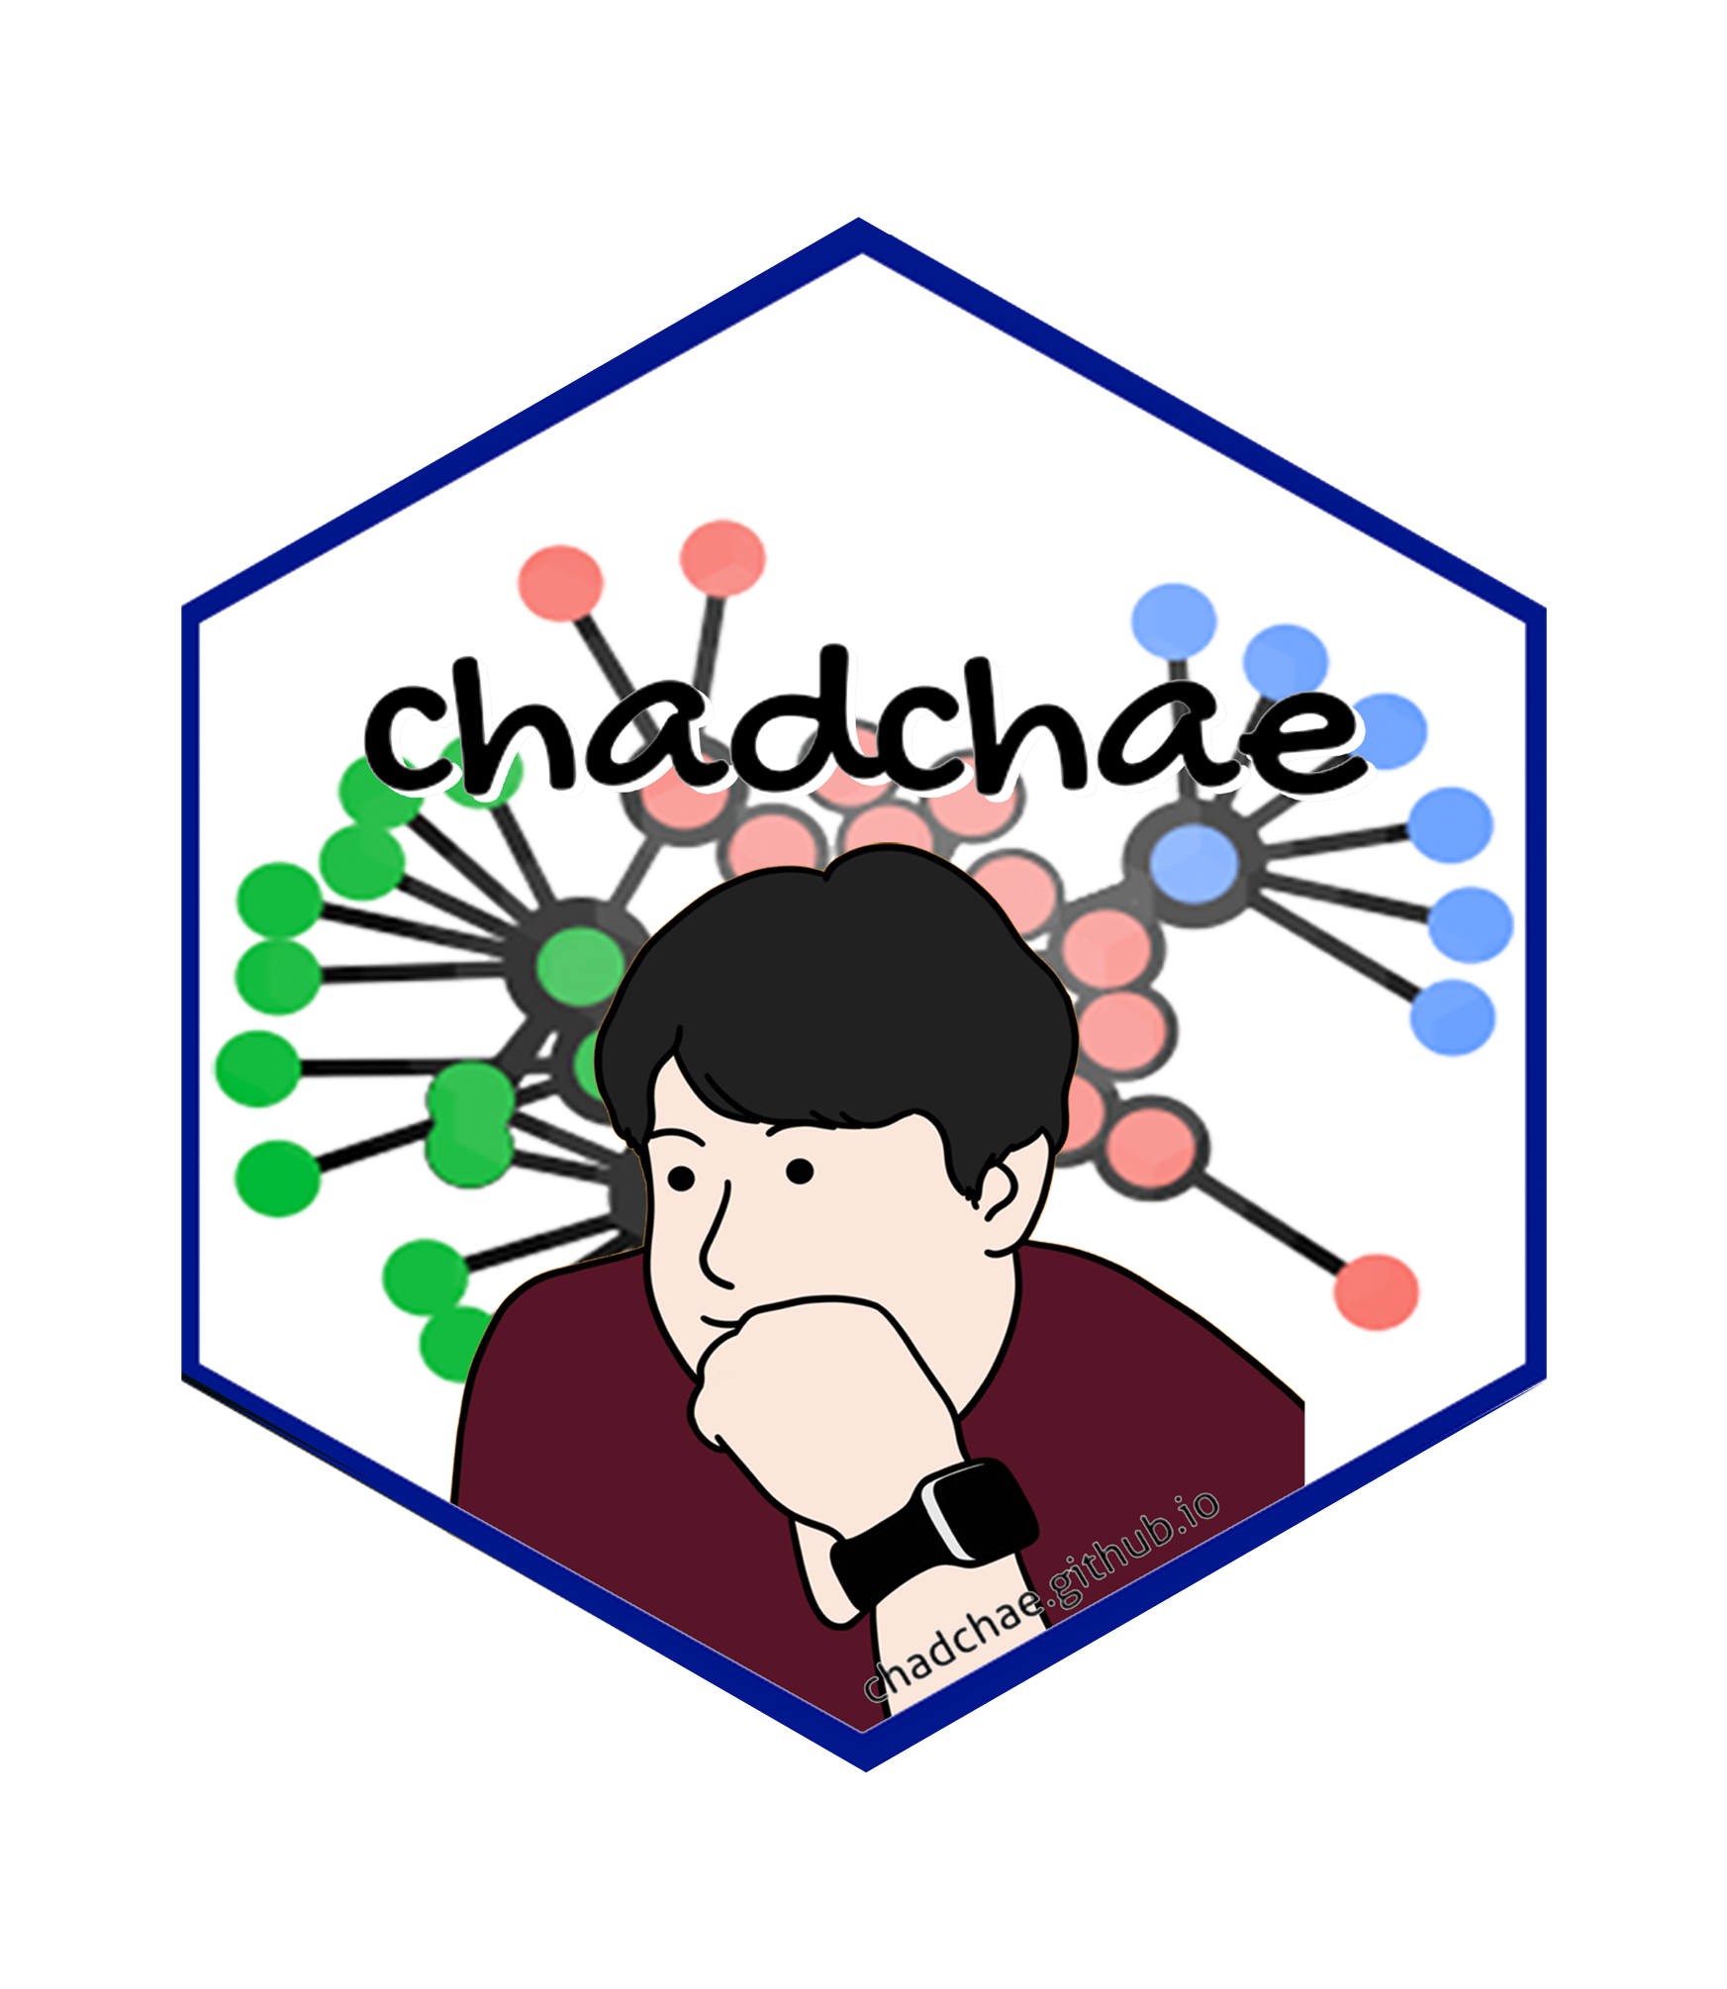
Chungil Chae Chae (2024) is an assistant professor in the field of business analytics, with a distinguished track record in organizational behavior, human resource development (HRD), learning, and development. With a prolific publication record that spans various dimensions of HRD and organizational studies, Dr. Chae has made significant contributions to understanding the dynamics of organizational support on knowledge sharing, virtual team leadership, and the structural determinants of HRD research collaboration networks. And his work embodies a deep commitment to enhancing understanding and practices in organizational behavior, HRD, learning, and development. His interdisciplinary research not only contributes to academic discourse but also offers tangible strategies for organizational improvement and individual development.

Qingtai Xu (Eren)
- xuqingtaieren@gmail.com
- Undergraduate Student
- Wenzhou-Kean University

Qingtai Xu is a junior student from Wenzhou Kean University who working under the supervision of Dr. Chungil Chae. His research focuses on. As a research assistant, Qingtai’s research interests are mainly focuses on human resource management, data analysis, business management and business analytics for strategic decision making. Qingtai has participated in internship programs of Fortune 500 companies and science popularization education programs carried out by the United Nations in Zhejiang, China. Through research collaborations and volunteer work, Qingtai has laid a solid foundation in the application of artificial intelligence systems, statistical modeling, data analysis and other aspects.

Acknowledgement
- tba

Declearation

IRB

Funding

AI

Research Log

xxxx-xx-xx
- entry.

Meeting Log

xxxx-xx-xx
- 10:00-10:30: Kick-off meeting

Analysis Version

Version 0.0.1
- Starting draft

Draft Version

Ver 0.0.1
- Starting draft

Ideas and Thoughts

Research Q & A

Procedures

Related Theories

Theortical Relationship

Theoritical Framework

Hypothesis

Methdology

Method

Data Collection

Data

Searching and Inclusion & Exclusion

Round 1

Search kewwords and category

keywords combination

Round 2

Search kewwords and category

keywords combination

Round 3

Search kewwords and category

keywords combination

PRISMA

Reference List
Category, Classification and Decision Note for Selected Literature in Rounds

Round 1

Round 2

Round 3

Additional (during and after writing)

Reserach Problems

Key References

Quotes and Paraphrases

Products

References
Chae, C. (2024). Introduction to chad (chungil) chae. https://chadchae.github.io

